Trey Haden

I am running for Deputy State Master Councilor because I feel like I can be a good representation for Virginia DeMolay.

Offices held:
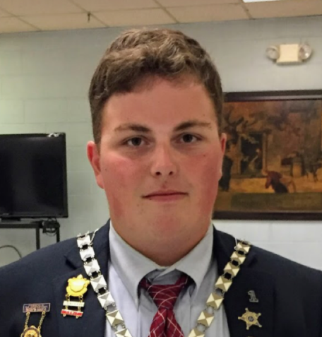
Master Councilor of Petersburg Chapter
Senior Councilor of Petersburg Chapter
Junior Councilor of Petersburg Chapter
Junior Deacon of Petersburg Chapter
Deputy Central Region Master Councilor

Honors/Awards:
PMC-MSA
RD
Founders Medal
Chevalier

Accomplishments:
4th section state champion
Conclave merit bar
Merit merit bar

